**Spring 2024: CS5720 Neural Networks & Deep Learning - ICP-3**

**Eekshitha Gujjala (700741491)**

GitHub Link: <https://github.com/Eekshi2001/Assignment3.git>

**1. Create a class Employee and then do the following**

Create a data member to count the number of Employees  
Create a constructor to initialize name, family, salary, department  
Create a function to average salary  
Create a Fulltime Employee class and it should inherit the properties of Employee class  
Create the instances of Fulltime Employee class and Employee class and call their member functions.

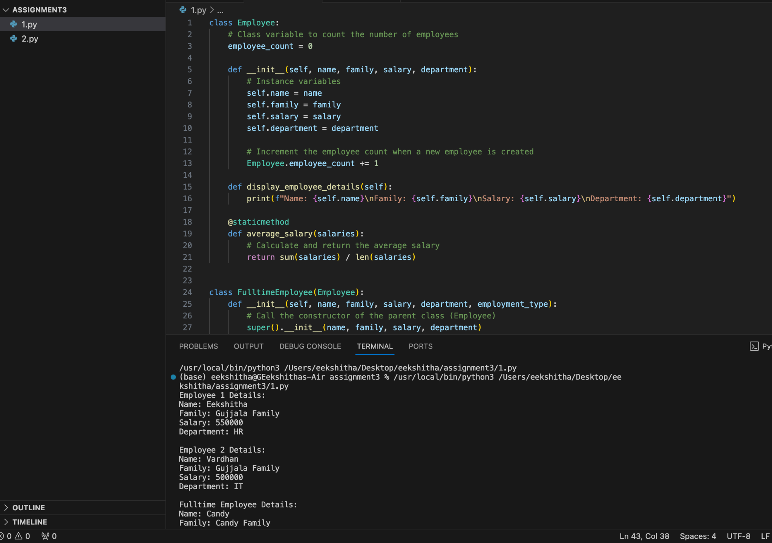

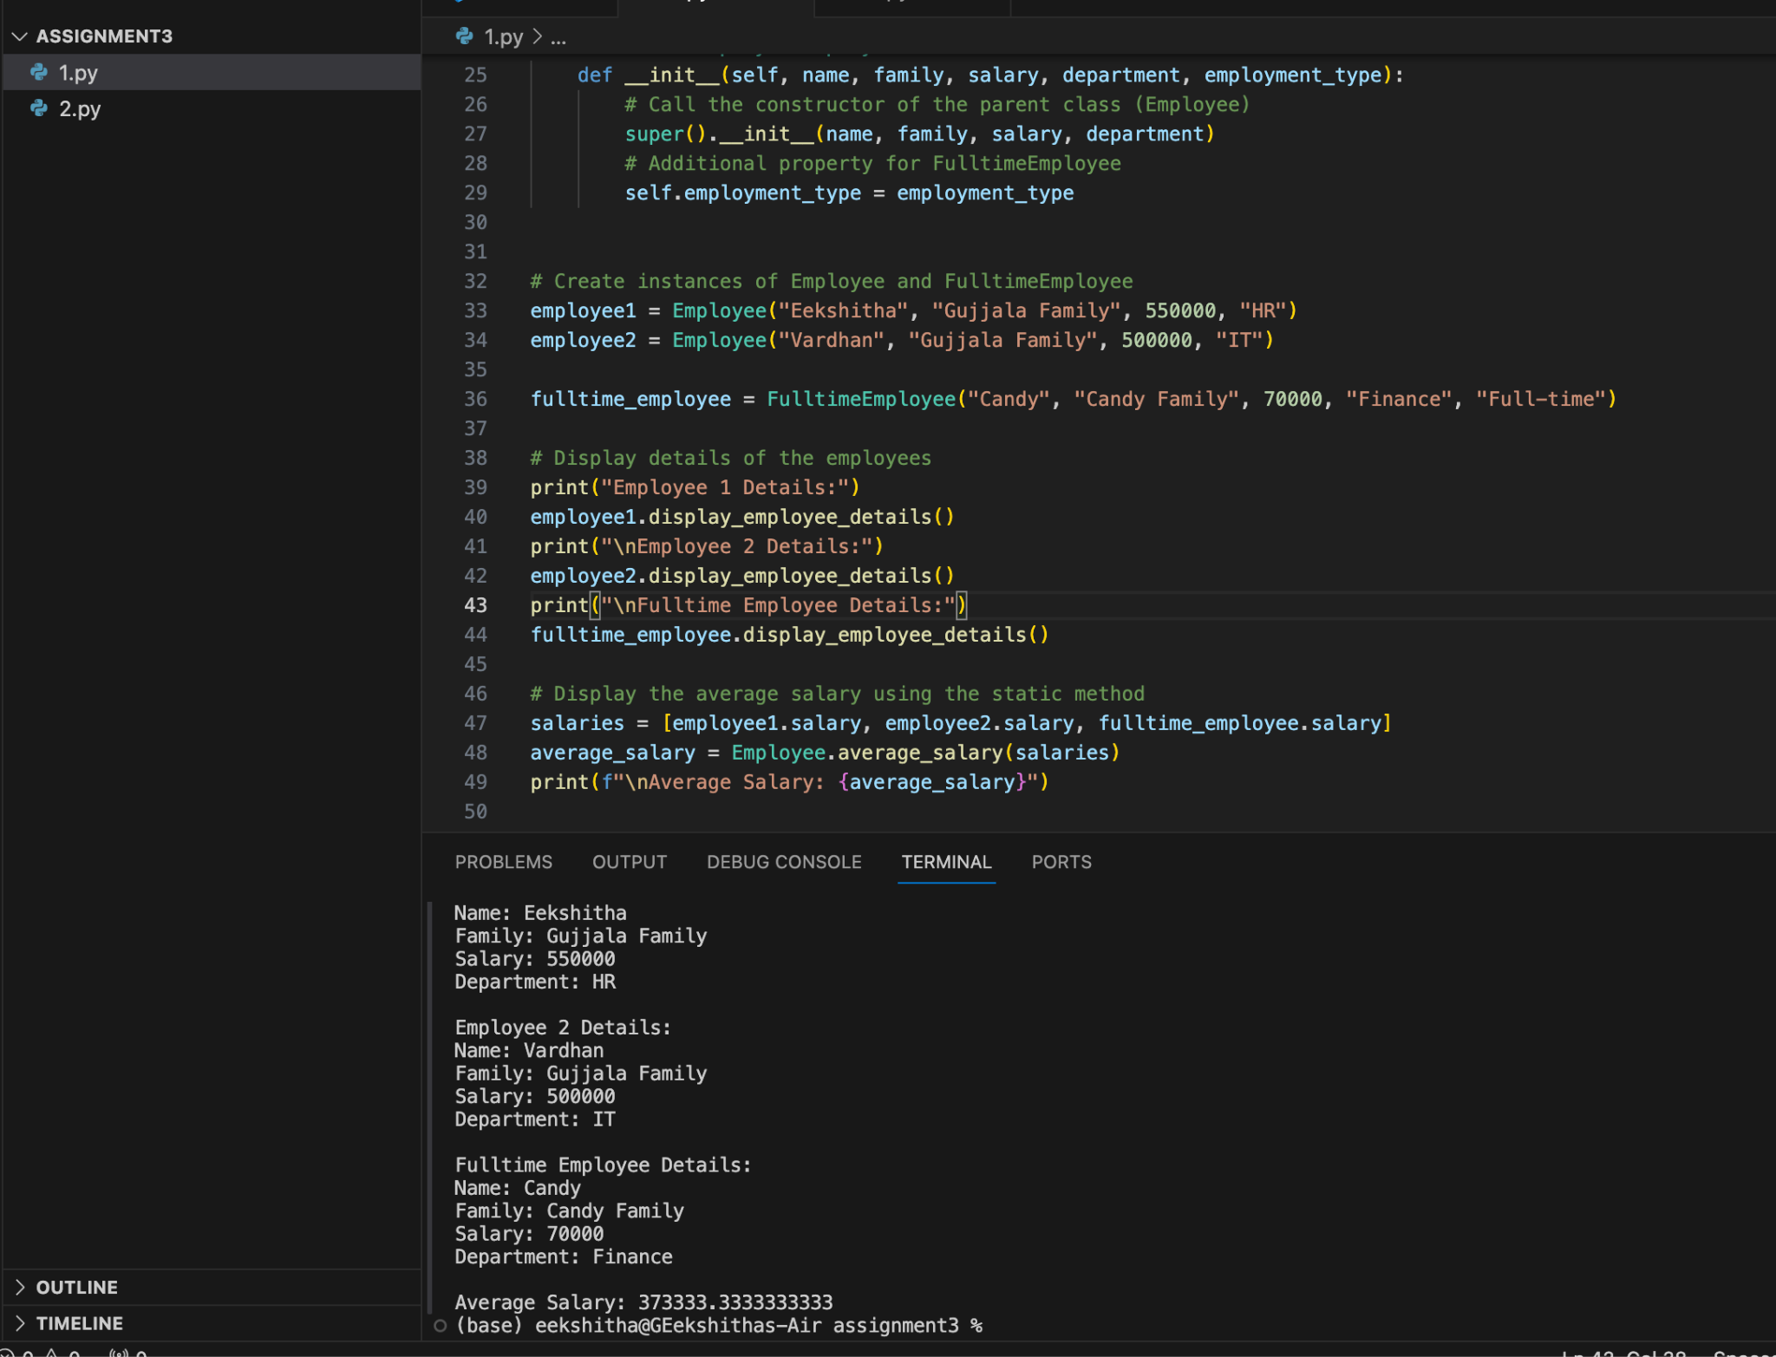

**2. Numpy**    
Using NumPy create random vector of size 20 having only float in the range 1-20. Then reshape the array to 4 by 5.Then replace the max in each row by 0 (axis=1)

